**A step-by-step process for installing UiPath studio**

**Step 1: Open the link in the browser-**<https://www.uipath.com/rpa/academic-alliance/academic-studio-download>.

**Step 2: Fill the contact details and choose the institution you belong to and then receive a link to download the software by email.**

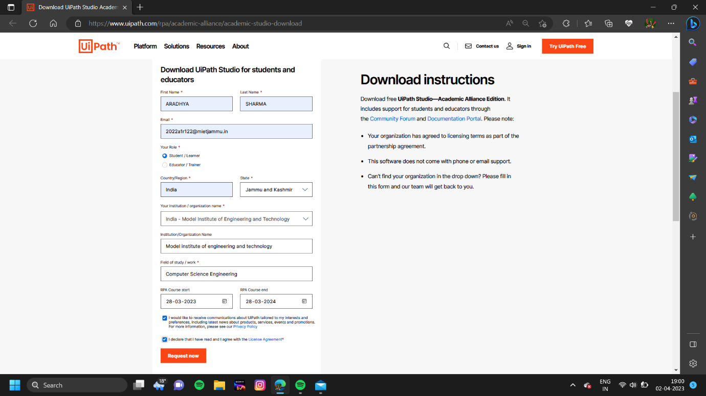

**Step 3: Click Request Academic Alliance Edition. Then, check your email.The email contains the link to download the UiPathStudio.msi file along with the dedicated license key. Click either the orange button or here.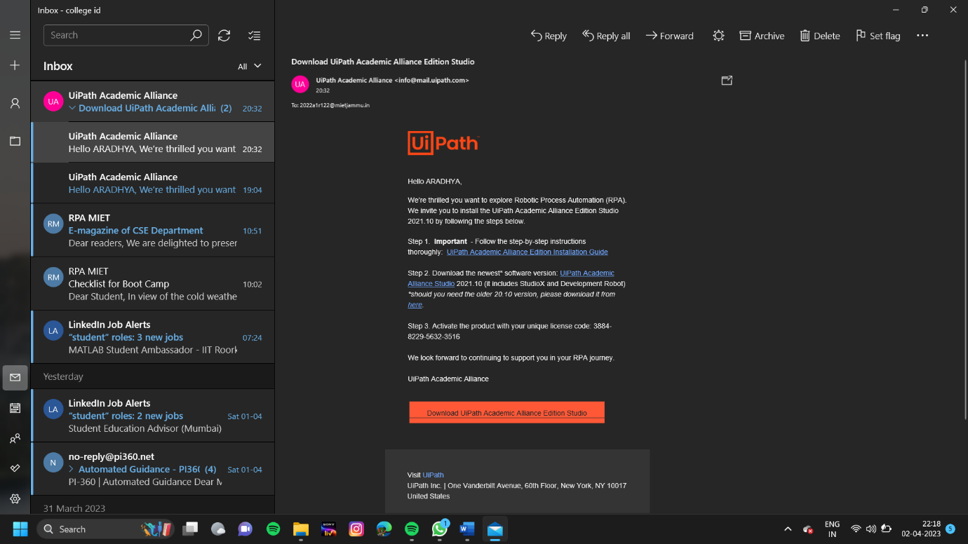 Step 4: The file will begin downloading. Click to open the UiPath Studio once it is downloaded.**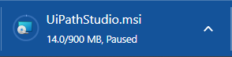

**Step 5: Accept the terms of the UiPath Studio License Agreement and click install.**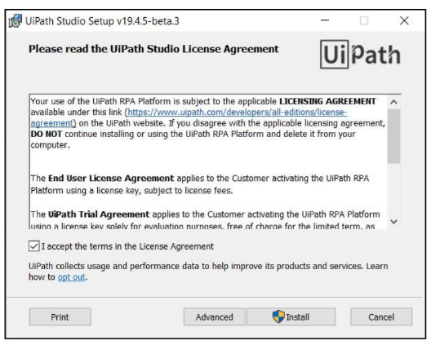

**Step 6: Make sure the Register as Windows Service option is deselected. To do this, click Register as Windows Service.**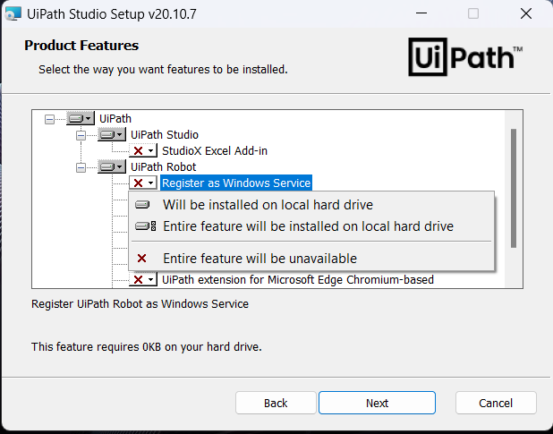

**Then, select Entire feature will be unavailable.**

**Step 7: Click Next to continue and then Install to begin the installation.**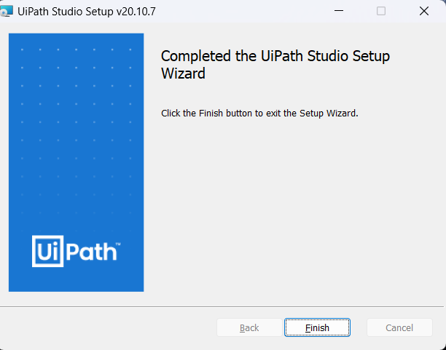

**Click Finish. If “Launch UiPath Studio” was checked, then UiPath Studio is launched.**

**Step 8: In the Welcome to UiPath Studio window, click Activate Stand-Alone License.**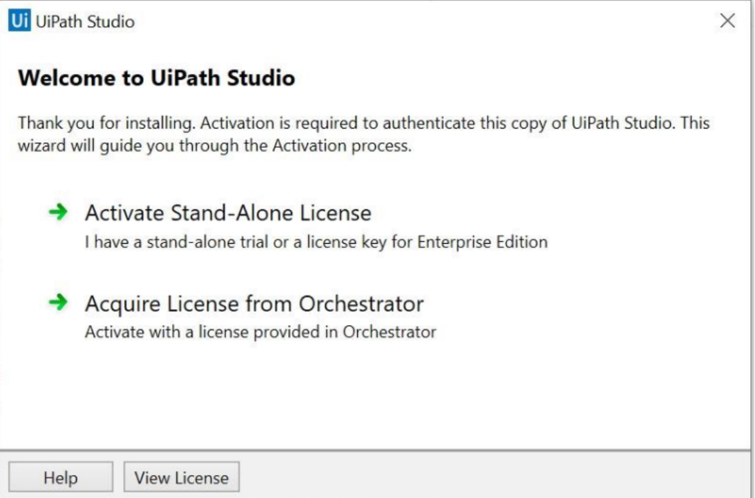

**Step 9: The UiPath Registration window is displayed.**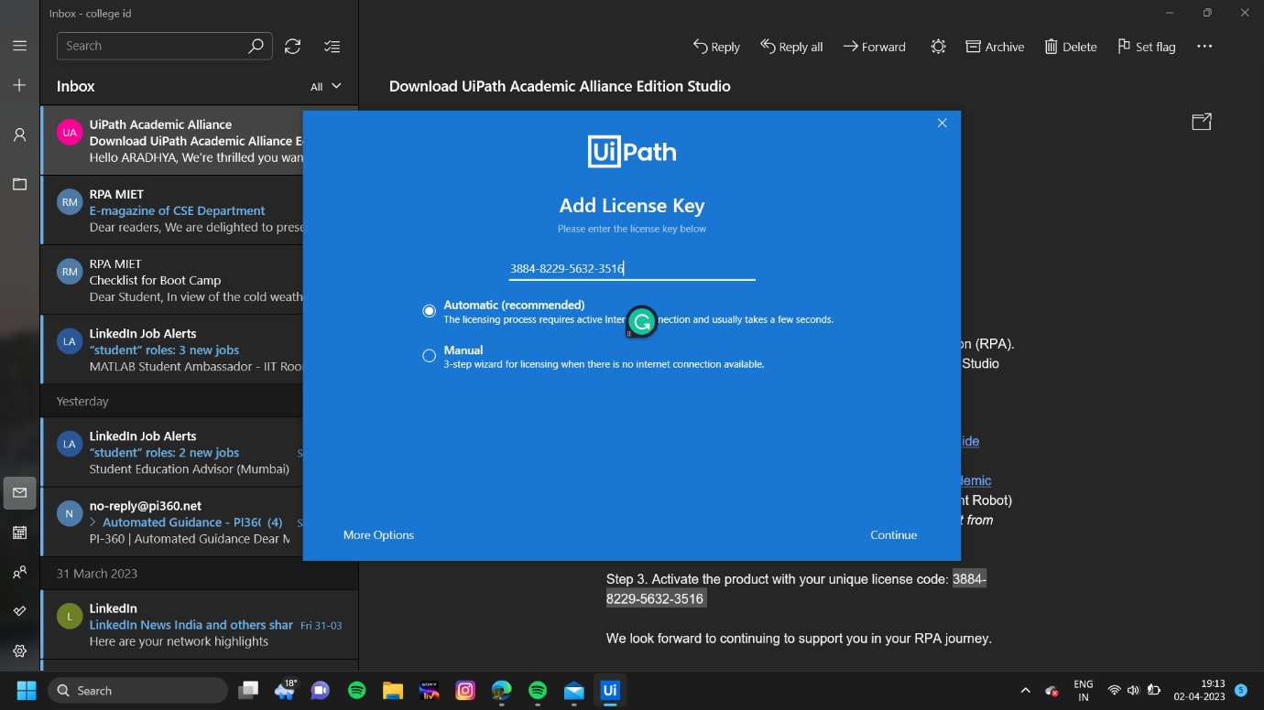

**a. Enter the License Key received by email.**

**b. Select Automatic activation.**

**c. Click Activate. Your UiPath license is now activated.**

**Now, you can start using UiPath software to create automation workflows.**

